Asia
Region
Funds
Passport

Annual Report 2016-2017

Annual Report 2016-2017

Chair Report
Jumpei Miwa
Chair of the Asia Region Funds Passport
Joint Committee
Director for International Capital Market Regulation
Financial Services Agency of Japan
Mr. Miwa (JP, center), Chair and Mr. McCarthy (Au, right) Vice Chair

It is our pleasure to publish the first edition of annual reports on the Asia Region Funds Passport (ARFP) which covers the activities from July 2016 to June 2017 in particular.
Thanks to each member’s cooperation, we have launched the first Joint Committee (JC) and agreed that the JC will have a role as a pragmatic body for the smooth implementation of the ARFP.
As we have seen with the UCITS framework in Europe where there have been historic efforts and successive developments, we can assume that we will face various challenges in the course of implementation. Under this assumption, it is key that we undertake all efforts and trials together in order to achieve feasible solutions.
In the past year, we have held two JC meetings and addressed issues such as fund back office processing and taxation, which will be of importance in implementation.
In the latter half of 2017 and early 2018, member economies have planned to coordinate necessary arrangements in domestic laws and regulations.
As part of the implementation support provided by the JC, the following agenda is important for the coming period.

(1)Transparency
The JC meetings are run by the member authorities and meetings are currently being held on a closed basis. It is key to consider how “openness” should be promoted in running these meetings.

(2) Communication
Better communication will enhance smooth implementation. In carrying this out, it is key to have more dialogue with relevant communities. As with the JC meeting in April where an industrial session was held, we will continue to seek opportunities for dialogue with industry practitioners.
The annexed application form (also known as the “A-form”) and the guidance paper released with this report are open for public consultation.

(3) Outreach
Considering the huge potential of the ARFP and financial sector developments in this region, further cooperation with Asia Pacific communities will be of importance. In understanding this, it is of the utmost importance to reach out to other member economies to encourage access to our frameworks.
Last but not least, I sincerely hope to develop the ARFP more extensively and to ensure the first export fund launches smoothly through this framework.

General Information

What is the ARFP?
The ARFP is an international initiative that facilitates the cross-border offering of eligible collective investment schemes while ensuring investor protection in economies participating in the ARFP.
In joining in the Memorandum of Co-operation (MoC) for the ARFP, participants share the goals of:
i. deepening the region’s capital markets to attract finance for economic growth in the region;
ii. strengthening the capacity, expertise and international competitiveness of financial markets in the region and the funds management industry, with a view to supporting sound economic development;
iii. facilitating the channelling of the region’s savings within the region, and growing the pool of funds available for investment in the region;
iv. providing investors in each of the economies with a more diverse range of investment opportunities, enabling them to better manage their portfolio and meet their investment objectives; and
v. maintaining the legal and regulatory frameworks which promote investor protection, fair, efficient and transparent markets for financial services, supporting financial stability and providing high standards in the management and distribution of collective investment schemes.

Biography
Sep 2015 Signing of the statement of understanding on the establishment of the ARFP at the APEC Finance Ministers’ Meeting.
*Six economies signed: Japan, Australia, Korea, New Zealand, the Philippines and Thailand.
Apr 2016 Signing of the MoC: Japan, Australia, Korea, New Zealand.
*Thailand also signed the MoC in June.
Jun 2016 The MoC entered into force.
*The ARFP will commence once any two economies have completed the implementation process and the signatories to the MoC to implement the necessary domestic arrangements by the end of 2017.
Nov 2016 The ARFP JC’s first face-to-face meeting in Kuala Lumpur, Malaysia.
Apr 2017 The ARFP JC’s second face-to-face meeting in Tokyo, Japan.

ARFP Investor Protection
Using this framework, when a fund is exported to other participating economy, the fund must comply with:
- the regulations of the home economy in which fund is registered as an ARFP fund;
- applicable regulations applying in relation to the offer of the fund in any host economy; and
- the ARFP rules.
This is expected to promote a high level of investor protection measures.
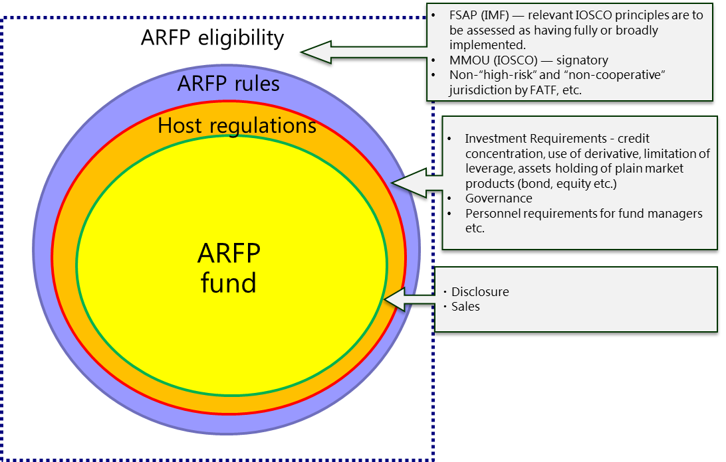

ARFP Framework
Efforts are made to unify the mutual entry processes for funds that are managed in accordance with rules agreed upon between securities regulating authorities.
Broadly speaking, when exporting investment trusts, it is necessary to prepare application documents that are compliant with the regulations of the export destination country. The procedures are complex with different assessment periods. However, under the ARFP framework, if funds are invested in accordance with ARFP rules, relevant authorities from the export destination economy are required to make an assessment of whether to accept the fund within 21 days in principle.

Summary of JC Meeting
First Face-to-Face Joint Committee Meeting
Grand Hyatt Hotel
Kuala Lumpur, Malaysia
Wednesday to Thursday, 23-24 November 2016

The ARFP JC launched the first face-to-face meeting in Kuala Lumpur, Malaysia on 23-24 November 2016, having previously held teleconferences.
The first meeting was held in Malaysia and the representatives were from Japan (Chair), Australia (Vice-Chair), Korea, New Zealand and Thailand. Representatives from Malaysia and Indonesia were present as observers.
The JC welcomed the involvement of officials from those economies and more broadly economies in the Asia region and noted that observing may assist in the consideration of these economies joining the ARFP scheme in the future. The JC also agreed to continue to reach out to other economies that were not participants.
The JC Members were keen to identify and act as needed to address any issues necessary the purpose of smooth implementation. The JC agreed on a path forward on the matters including:
- developing a content design and management policy for the ARFP official website (http://fundspassport.apec.org/) in a transparent and effective manner for operators and investors;
- preparation of a draft Part A, the proposed common fields of an application form to be used by ARFP funds;
- sharing updates on the progress for implementation of the ARFP in member economies toward the commencement of the ARFP in late 2017;
- further development of the guidance documents providing general information about the related regulations in the participating economies ; and
- understanding taxation issues relating to the ARFP funds.
The JC sought input from a variety of sources to understand the context in which the ARFP would operate.

Summary of JC Meeting
Second Face-to-Face Joint Committee Meeting
Financial Services Agency, Japan
Tokyo, Japan
Thursday to Friday, 20-21 April 2017

The ARFP JC held its second face-to-face meeting in Tokyo, Japan on 20-21 April 2017.
The second meeting of the JC was held in Tokyo, Japan and was attended by representatives from Japan (Chair), Australia (Vice-Chair), Korea, New Zealand and Thailand.
The JC received updates on the progress of implementation of member economies. The JC also discussed information sharing, developing common elements in the application form to be used by ARFP funds and the feasibility of a pilot study with industry as a part of the implementation process.
The JC agreed:
- to publish this Annual Report in July and include information about progress in preparing for the operation of the ARFP;
- to publicly consult on draft guidance about laws and regulations that are expected to apply to imported funds in “host” passport economies in July;
- to continue to engage with and reach out to other economies in the Asia region that are not yet participants; and
- for Australia to chair a working group of tax specialists to consider what information can be given to funds and investors about tax treatment and to what extent taxes or taxation arrangements would be a barrier to the effectiveness of the ARFP.
The JC continued to engage with industry to understand the practical issues affecting the ARFP. The JC had interactive discussions with Japanese fund managers and distributors interested in the ARFP following presentations from the Japan Securities Dealers Association (JSDA) and the Japan Investment Trusts Association (JITA).
The JC appreciates the value of continuing open and consultative approach with the industry in the development of the ARFP.

The Development of pre-Implementation in Member Economies

[Australia]  In Australia, the MoC is being implemented into draft legislation, which will be consulted upon shortly. Australia is also developing legislation for a corporate collective investment vehicle (CCIV). The CCIV is intended to support the establishment of the ARFP as it has a corporate structure similar to that of European-style funds already familiar to many investors in Asia. | ASIC is working closely with Australian Treasury to implement the passport. ASIC represents Australia on the ARFP’s JC, which is responsible for aspects of the implementation of the ARFP. ASIC is currently focusing on developing guidance to industry, as well as internal and registry processes to facilitate use of the ARFP. This will include developing registers of ARFP funds that will operate under the ARFP regime and new IT infrastructure for ARFP funds. Australian and foreign operators will be able to register or notify ARFP funds to ASIC through an online portal using a digital form.

[Japan]  The Japanese government will take necessary domestic arrangements in accordance with the ARFP rules including amendment of its regulation (the Cabinet Ordinance of Financial Instruments Exchange Act) by the end of 2017.  FSA has been working with the self-regulating organisations (SROs) of JSDA and JITA, to install new SRO rules together with regulatory amendment. Japan is expected to be ready to accept incoming ARFP funds from the beginning of 2018. | The SRO regulating asset management companies has prepared an ARFP Checklist based on the MoC as a part of the application documents. The SRO plans to request submission of the Checklist and the Application Form Part A in addition to notification documents.

[New Zealand]  In New Zealand, new regulations need to be passed to ensure that both overseas and New Zealand ARFP funds can use the funds passport in New Zealand and in other member jurisdictions, as applicable. Those regulations will provide overseas ARFP funds with exemptions from certain requirements of New Zealand law, so that offers can be made in accordance with the ARFP regime. | We are targeting finalising the regulations by late 2017 in order to be ready for full implementation of the ARFP regime by the end of 2017.

The Development of pre-Implementation in Member Economies

[Kingdom of Thailand]  Since the MoC came into effect on 30 June 2016, the SEC Thailand has undertaken a focus group with relevant stakeholders to explain and build a common understanding of the final version of the ARFP Rules and has conducted a public hearing on Host Economy’s Law and Regulation relating to the ARFP to seek industry’s concerns and comments on fund offering to other host jurisdictions in which they have interest.  At present, SEC Thailand is in the process of drafting and issuing relevant regulations to accommodate the cross-border offering of the ARFP funds through the ARFP framework which aims to commence in 2018. | As the necessary works of preparing the regulations come under the purview of the SEC Thailand in conjunction with SEC Thailand’s experiences gained from implementing the rules and procedures for ASEAN Collective Investment Schemes (CIS) framework, the SEC Thailand is of the view that all relevant regulations will be well prepared to meet the target timeline. In the interim, SEC Thailand is also looking for a potential Thai asset management company that is keen to establish a pilot ARFP fund, as proposed by the JC, to have preliminary discussions in order to encourage, provide guidance and informal steers to build readiness prior to the launch of ARFP framework.

[Republic of Korea]  The Korean government is preparing a legal amendment for the implementation of the ARFP. The amendment aims to provide regulations broadly covering the management of an ARFP fund, including its registration, sales and operations. The relevant authority is currently working with Korea Financial Investment Association (KOFIA), asset management firms and legal and other experts to systemise the ARFP. The official procedure for legal amendment is planned for the second half of 2017, after the draft amendment has been prepared. | While there is a rising interest in outbound business using the ARFP among large investment firms, specific movement is yet to be seen. It seems likely that there will be more substantial response after the regulatory scheme becomes more visible throughout the latter half of the year.

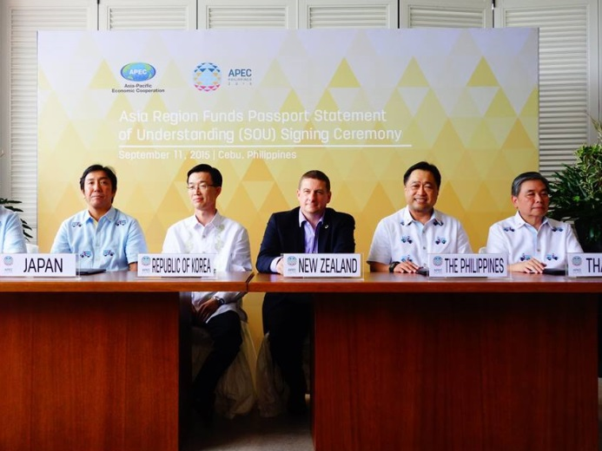 | Non-Participant — Engagement

The JC has continued an active process of engagement with other economies in the Asia region that might be interested to join the ARFP. For example, at the first face to face JC meeting, officials from Indonesia engaged in discussion and officials for Malaysia attended as observers. At another meeting, officials of the Monetary Authority of Singapore explained Singapore’s position about participation.
Australia has taken a number of steps in engagement. Prior to the release of the legislative package in Australia, the draft legislation for both the ARFP and CCIV frameworks has been shared with representatives from other ARFP economies such as New Zealand. These ongoing discussions have helped facilitate the sharing of information and experiences to assist with the drafting and consultation process. While developing its new CCIV proposal, Australia has benefited from input from ARFP economies and Singapore. Australia has also been engaging with ARFP economy industry representatives on the implementation of the ARFP in Australia.
In addition, Australia has undertaken capacity building steps with Indonesia to assist Indonesian officials in their assessing and decision making about participation and has plans for further capacity building activities. Australia has also engaged with officials of the Securities and Exchange Board of India to provide information about the ARFP and eligibility criteria. The JC supports these initiatives.
The Philippines, which aims to be a member of the ARFP, is currently not eligible to be a member as it is not a signatory under the International Organisation of Securities Commissions’ Multilateral Memorandum of Understanding Concerning Consultation and Cooperation and the Exchange of Information (IOSCO MMoU) Appendix A. Japan has had an active role in assessing the Philippines’ ability to become a signatory to IOSCO’s MMoU.

Progress of Tax Issues

Australia will convene a meeting of the Tax Reference Working Group bringing together tax specialists from participating and prospective ARFP economies which will highlight the importance of tax neutrality between ARFP economies to the effective implementation of the ARFP. This Working Group will reinforce the open and consultative dialogue between ARFP economies and will provide a good opportunity to reiterate that the tax treatment of funds and investors in the ARFP should not be a barrier to greater market access.
Domestically, Australia continues to take steps to improve the competitiveness of the Australian funds management industry, including through adjusting its tax settings. These include legislating the Investment Manager Regime, and announcing a tax and regulatory framework for a new CCIV. This new CCIV will provide prospective investors with access to a passive investment vehicle with flow through taxation, using vehicles commonly used overseas and which will be regulated as a financial services product under Australia’s financial services regime. Following the implementation of this new CCIV, the Australian Government will turn its attention to establishing a Limited Partnership Collective Investment Vehicle to further expand the suite of service offerings available to Australian fund managers.

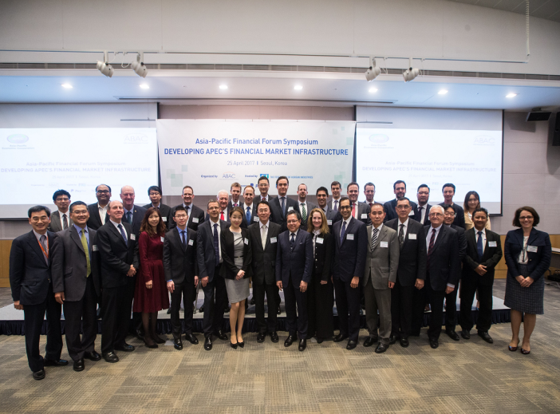 | Fund Back-office Processing

To promote better understanding of issues and challenges related to fund back-office processing, in April 2017, the JC took part in the Asia Pacific Financial Forum (APFF) in Seoul, Korea, to discuss a range of topics including ARFP funds, fund service infrastructure, and fund back-office standardization. In regards to passporting schemes, the importance of a standardized fund registration process in the ASEAN CIS framework, as well as the successful establishment of a pilot fund in the China-HK Mutual Recognition for Funds (MRF) were highlighted. The discussion on fund back-office processing focused on the need to harmonize different business processes and terminology used between markets. In addition, the JC took note of the activities undertaken by a consultative group on fund back-office processing standardization (AFSF) led by national central securities depositories in the region.
Fund back-office processing refers to the administrative activities that follow a trading order, including account opening, order routing/execution, book-keeping, registration, settlement, etc. between market players. Currently, fund back-office operations across Asia see a prevalence of disparate practices, manual interventions, and proprietary systems. The JC will continue to support discussion related to fund back-office processing, in order to enhance efficiency and accuracy for fund market players seeking to engage in the trading of ARFP funds.

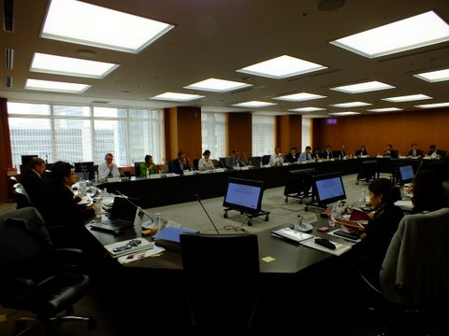 | Industry  Outreach

Members of the JC continue to reach out to industry and officials in Asia region economies. For example, at this year’s APFF, a JC representative presented the development of the ARFP. This was followed by the discussion about fund services relating to the ARFP with participants from the financial market industry in the Asia Pacific region.
It was pointed out that the ASEAN CIS experience indicates it is important to have standardized fund entry processes for funds between ARFP economies, in order to ensure that benefits of streamlined regulations are felt by the market. It was suggested that the case of China-HK MRF shows that establishing a pilot fund and checking the operation of passporting should be beneficial in promoting the ARFP scheme.

Agreed Items of Application Form Part A

*Please note that these are the minimum items required to be disclosed to respective economies. Additional items can be added subject to each regulator’s requirements.
A. Fund information | Passport Rules Reference
1. Name of the passport fund | Not specified
2. Details of the passport fund (e.g. legal structure and type of the passport fund) | Not specified
3. Permitted investments, restrictions on portfolio allocation, limits on exposures and other restrictions (supporting document may be required, if necessary) | Annex 3 Part 6 and 7
4. Offer in home economy (supporting document may be required, if necessary) | Annex 3 Section 17
5. Fees and charged to performance fee | Annex 3 Section 47
6. Details of auditor | Annex 3 Section 16
7. Information whether the constituent documents have been updated to reflect the passport Rules. | Annex 3 Section 4
B. Operator of the fund
1. Name of licensed operator and business name | Not specified
2. Address of registered office and principal place of business | Annex 2 Section 3
3. Contact details | Not specified
4. Eligibility of operator
4.1) Total asset value under management | Annex 2 Section 3(4), (5)
4.2) Officer qualifications | Annex 3 Section 6
4.3) Financial resources | Annex 3 Section 7
4.4) Organizational arrangements | Annex 3 Section 8
4.5) Track record of operator or related party | Annex 3 Section 9
5. Delegation of functions by operator | Annex 3 Section 11
5.1) Delegation of functions or sub-delegation to other entity (if any)
5.2) Name(s) and economy(ies) of the delegated entity(ies) (if delegate investment management functions to other entities for more than 20% of the value of the fund’s asset)
C. Relevant party
1. Distributor(s) | Annex 1 Section 2(3)
1.1) Contact information in home economy and in host economy, if possible (e.g. name of distributor, address, telephone number)
2. Custody of the passport fund asset | Annex 3 Section 13
2.1) Contact information (e.g. name of custodian of the fund assets, address, telephone number)
3. Independent Oversight Entity of the fund | Annex 3 Section 14
3.1) Contact information (e.g. name of independent oversight entity, address, telephone number)
4. Annual Implementation Reviewer | Annex 3 Section 15(3), (4)
4.1) Contact information (e.g. name of implementation reviewer, address, telephone number)

